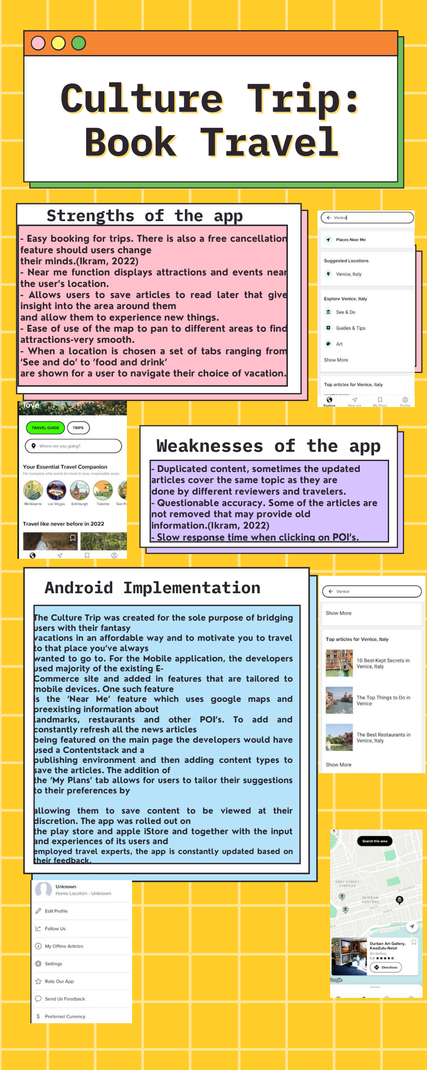

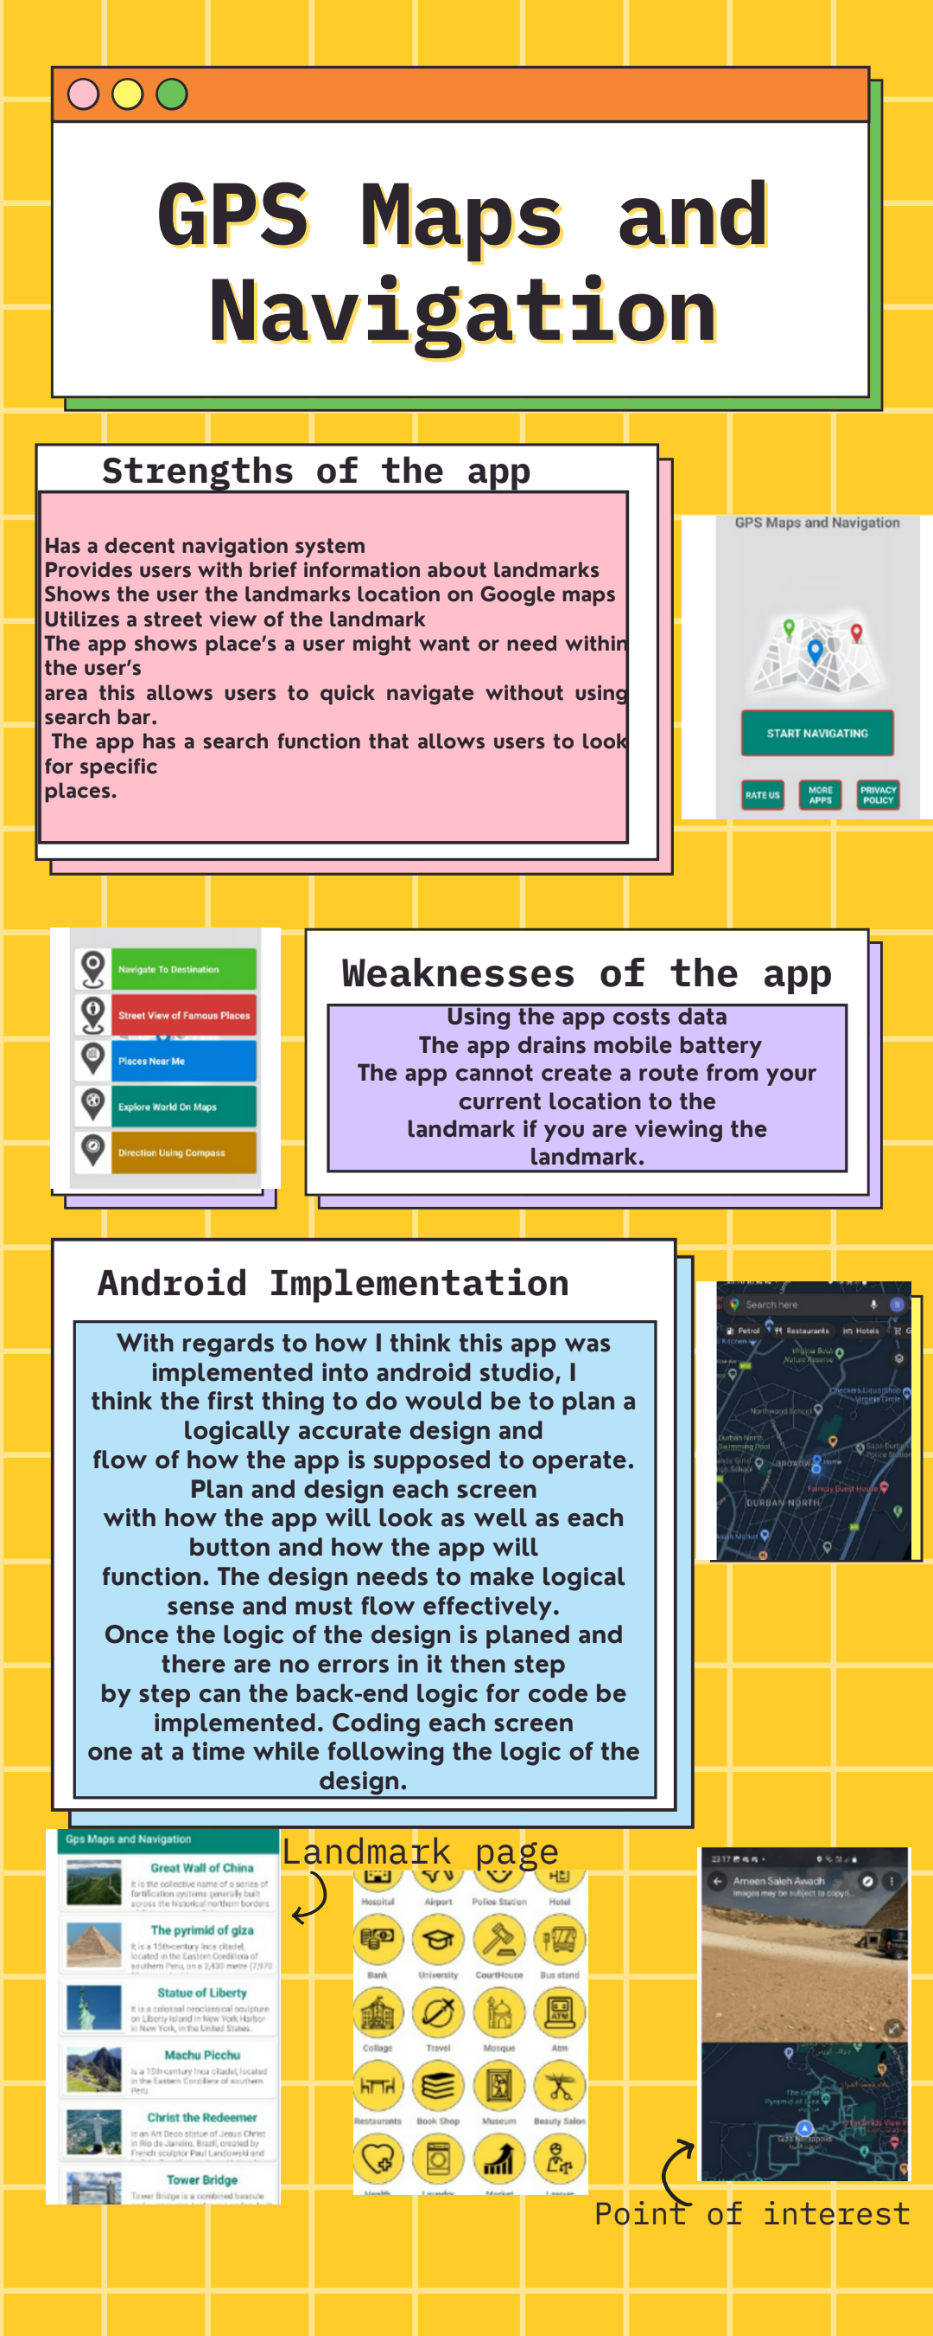

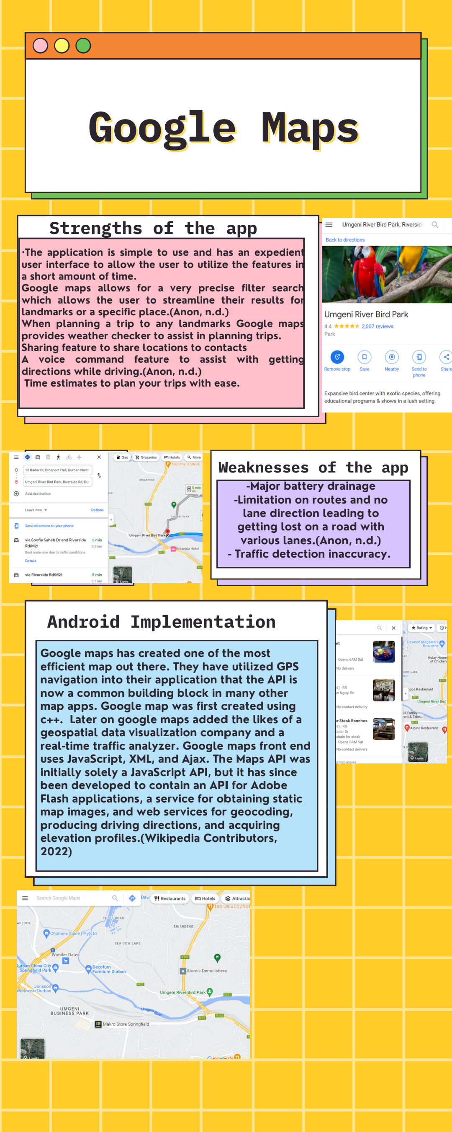

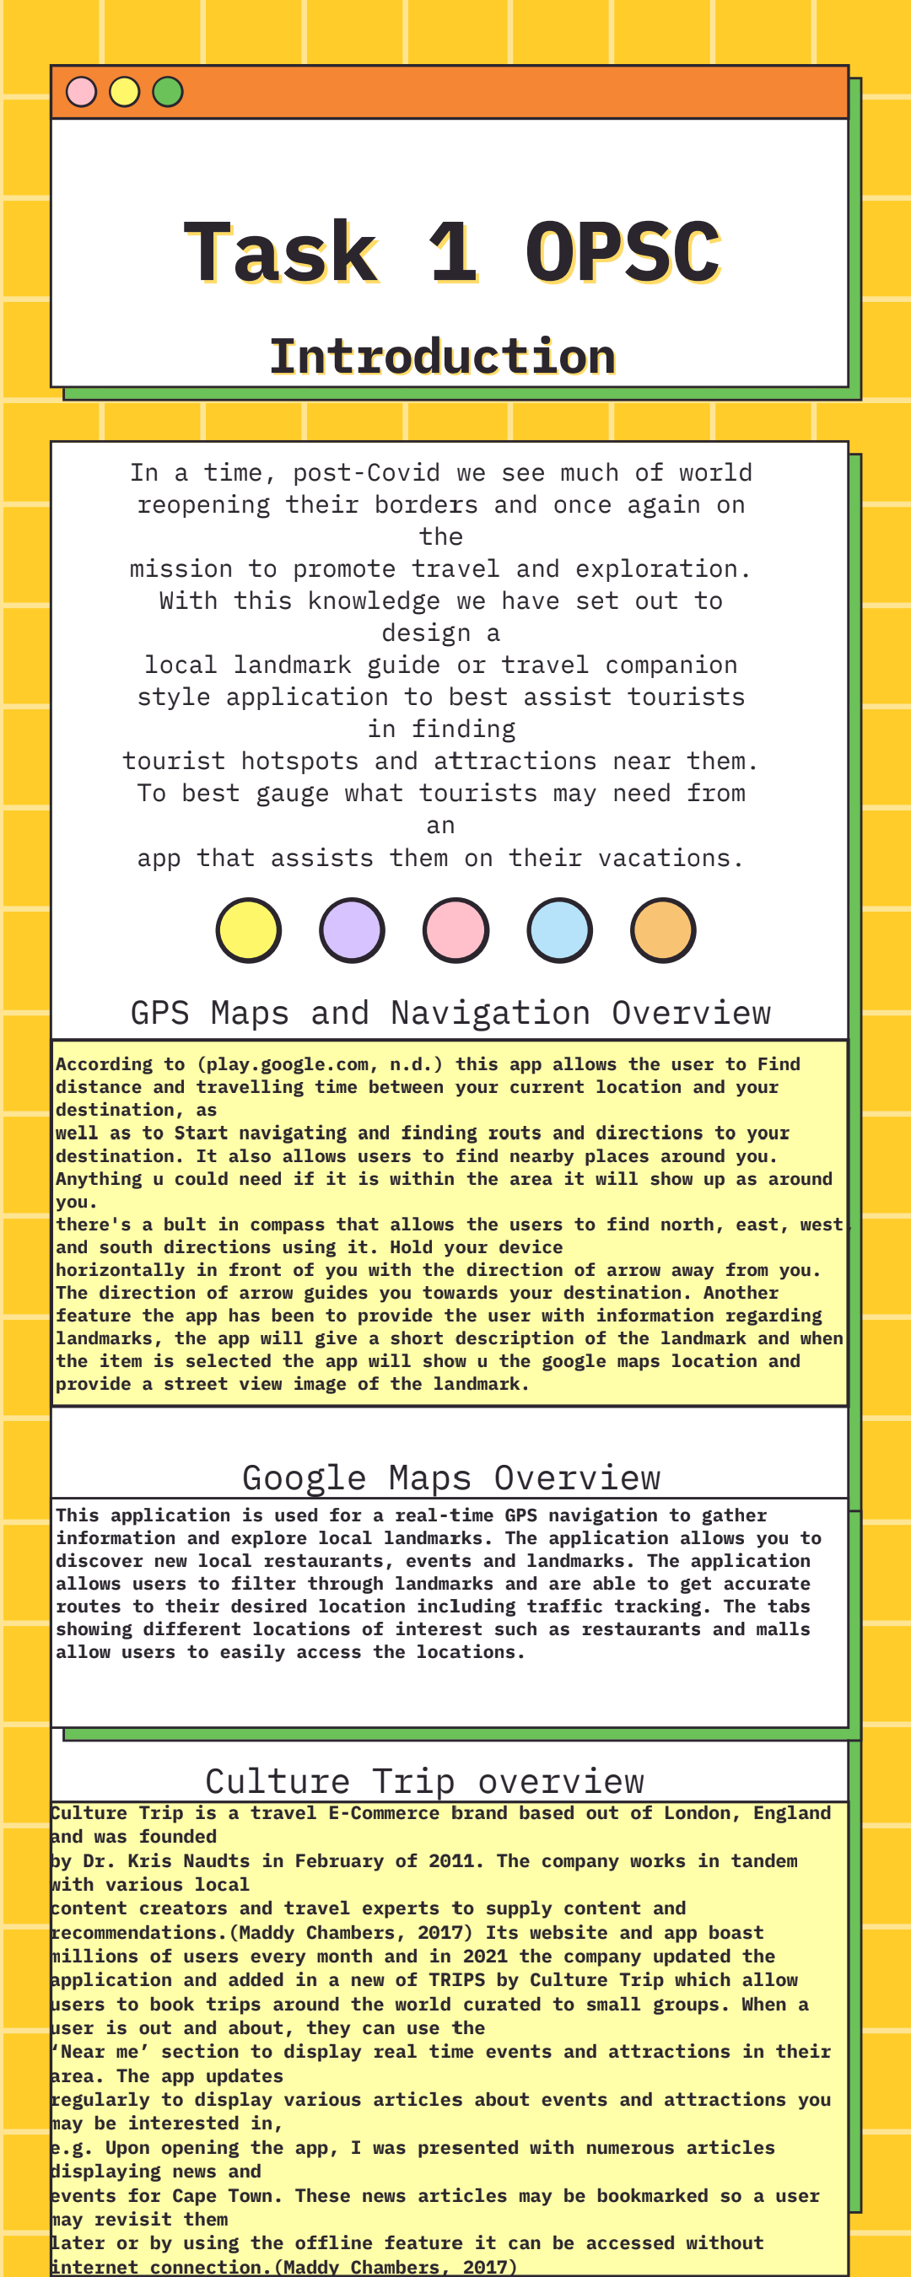

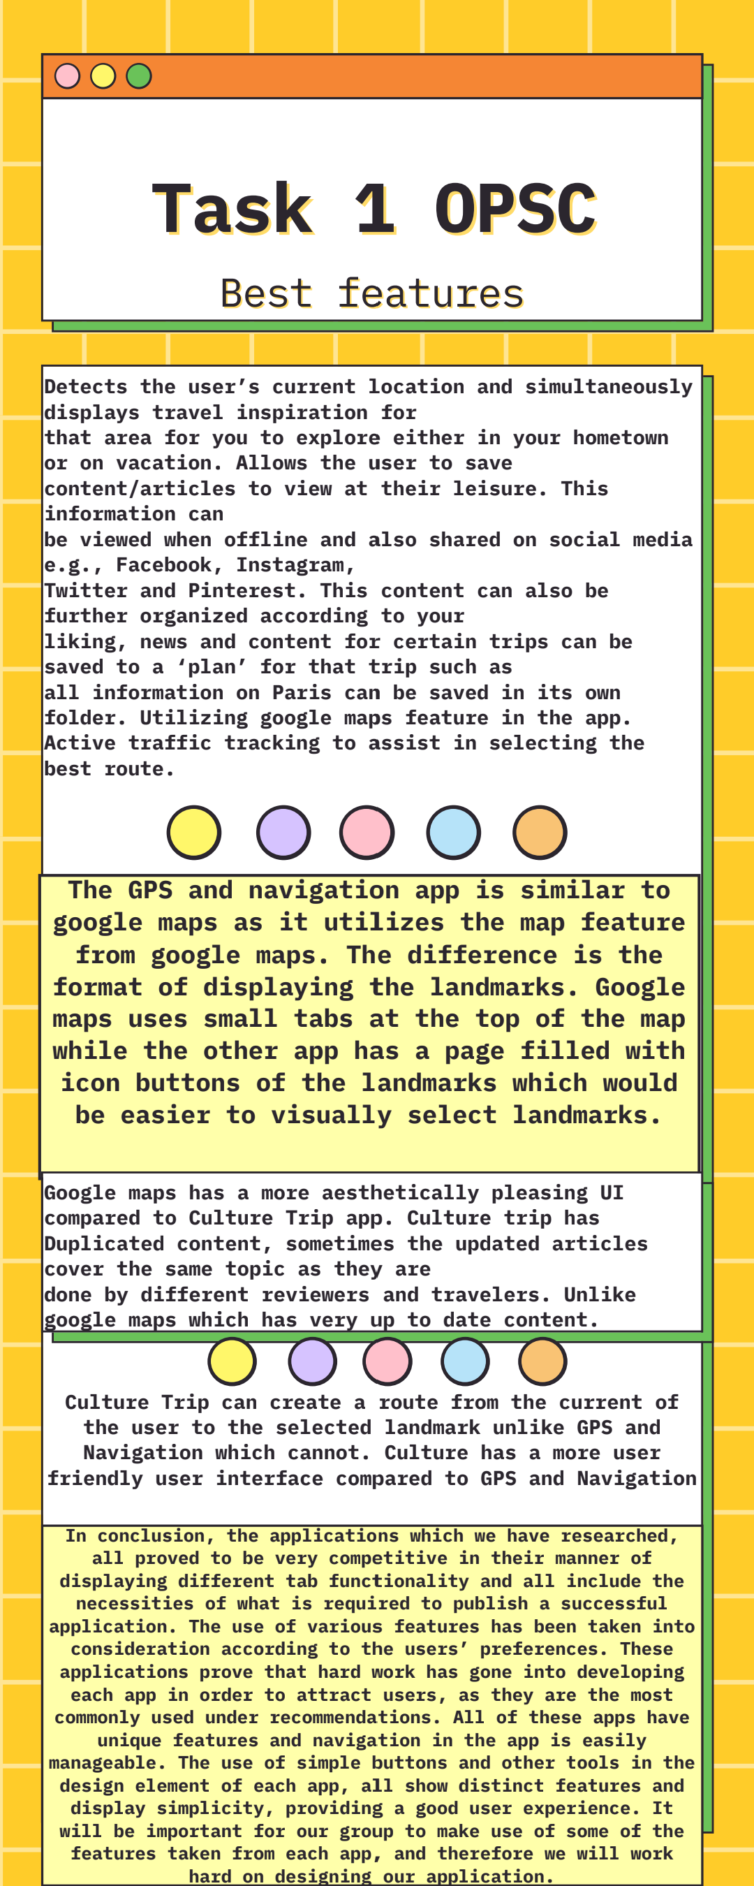

**Research Feedback**

Based on the feedback we received in Task 1, we have updated our research and design document to include more detail of features we included in the app.

In terms of data listing.

* Picture (PNG files). This is for all visual aspects of the app eg, when a user clicks on a location for a monument an image will appear showing the monument itself.
* Location data. This data is used to pinpoint the user’s approximate location and chart a route to their desired destination.
* User data (personal information). For users to customise and personalise the app to their needs.
* Link with Google Maps for location.
* External data share. Allowing the user to link their app to social media so they can share their photos.

In coding and implementing the app we used the apps researched as inspiration for similar features.